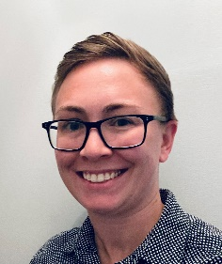

Bio: Samantha Forrest, Corteva Agriscience;

Samantha was born and raised in Baltimore, MD; where she currently resides. She has been a part of the pest industry for over 10 years. She is the current Territory Manager for Corteva Agriscience, focused on Sentricon and ActiveSense, all along the east coast. Samantha’s previous role was Director of Operations for Brody Brothers Pest Control, where she was involved with business strategy, development and growth. Keeping in stride with her love for the Pest Management Industry, she is also the current President of the Maryland State Pest Control Association, in her second-term.

